NAME : K.Avinash
REG NO: (192412662)
COURSE NAME : 5G 6G COMMUNICTION (ECA5601)
DATE : 12/08/2026

EX NO: 1 | Simulation of FDMA in MATLAB

Aim: To simulate a Frequency Division Multiple Access (FDMA) system using MATLAB and analyze its communication performance in terms of channel bandwidth, data rate, and signal-to-noise ratio (SNR).
Objective 1:
To simulate an FDMA system by allocating individual frequency channels to multiple users and determine the channel bandwidth assigned to each user.
Output Parameter: Channel Bandwidth (kHz) Procedure :
- Open MATLAB and create a new script file.
- Define the total available bandwidth, number of FDMA users, carrier frequencies, signal power, and noise power.
- Allocate a unique frequency channel to each user and calculate the channel bandwidth.
- Compute the data rate for each user based on the allocated bandwidth and modulation scheme.
- Calculate the Signal-to-Noise Ratio (SNR) using the signal and noise power values.
- Plot the transmitted signals of all FDMA users using different carrier frequencies.
- Display the calculated channel bandwidth, data rate, and SNR in the MATLAB Command Window.
- Analyze the results to verify independent channel allocation and evaluate the overall performance of the FDMA system.
Program (Matlab Code) :
clc; clear; close all; fs=1000; t=0:1/fs:1;
TBW=600; Users=3;

CBW=TBW/Users; fc=[100 300 500]; m=sin(2*pi*10*t); s1=m.*cos(2*pi*fc(1)*t); s2=m.*cos(2*pi*fc(2)*t); s3=m.*cos(2*pi*fc(3)*t); subplot(2,1,1)
plot(t,s1,'r',t,s2,'g',t,s3,'b'),grid on title('FDMA Channel Allocation'),xlabel('Time (s)'),ylabel('Amplitude') subplot(2,1,2) bar(1:Users,CBW*ones(1,Users)),grid on xlabel('Users'),ylabel('Channel Bandwidth (kHz)'),title('Channel Bandwidth per User') OUTPUT:

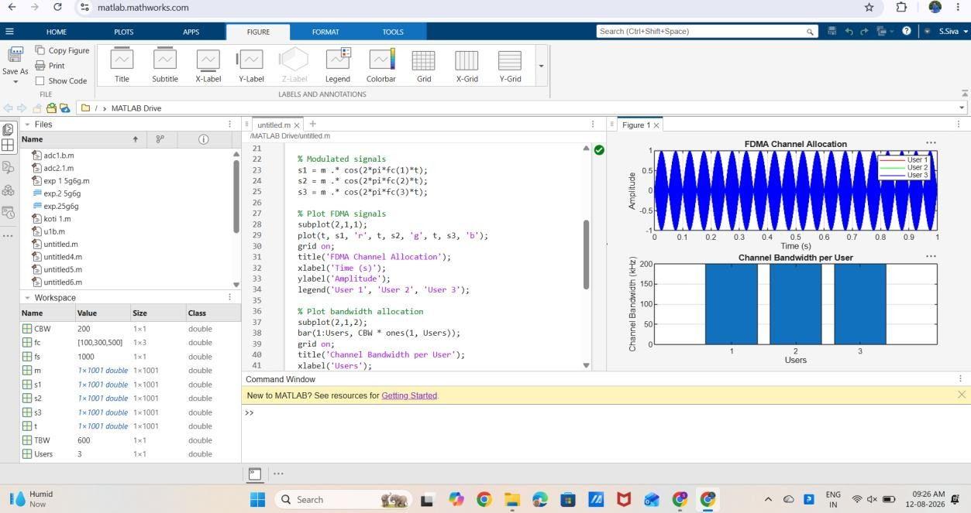
Result:
Displays three users transmitting on different carrier frequencies (100 kHz, 300 kHz, and 500 kHz).
• Demonstrates that each user occupies a separate frequency channel.

